**Diagnosis Tool Box**

This tool is useful for Technicians to repair the electric cycles.

Testing of electric cycle components

1. ***Throttle***

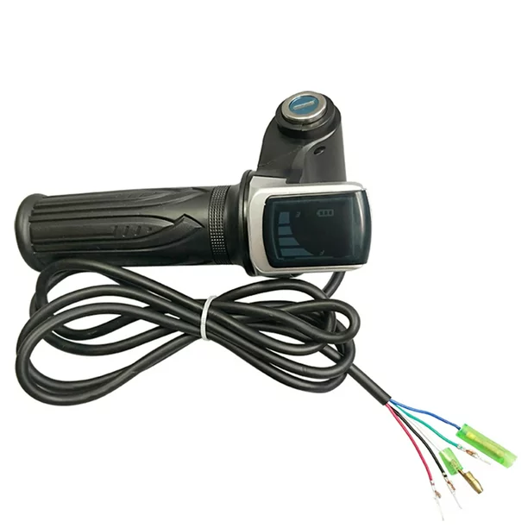

***PIN DESCRIPTION***

The red pin indicates the power for throttle,the black pin for ground, green pin for the signal (output from the throttle) , yellow for the battery level indicator and white pin for the power of the cycle (when key is ON it is connected to battery)

***TESTING***

When connecting the red pin to 5 volt and black to GND we observe the green pin output from the analog read pin of the arduino. It is observed that when the throttle is not raised the min voltage value that green pin must give is 0.8 and at highest throttle gives 4.2 volt.

***Note***

When testing with an arduino and reading values from an analog read pin to get the exact values, calculate the 5 volt value of the arduino from the multimeter because it is not 5 volt exactly.

Analog read value =

analogread(pin number)*(value of 5 volt pin calculated from arduino)/(1024)

1. ***Pedal Assist (PAS)***

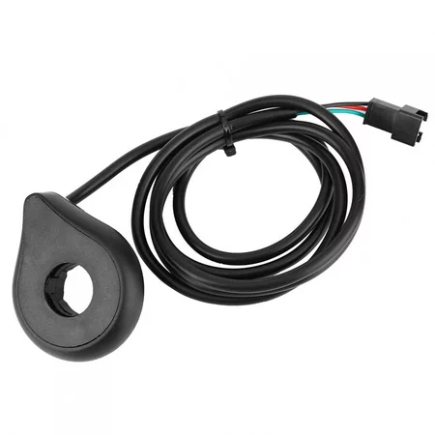

***PIN DESCRIPTION***

The red pin indicates the power for PAS , the black pin for ground, green pin for the signal (output from the PAS).

***TESTING***

The output voltage values from the green pin are observed in the arduino and noted down . When the PAS is turned anti clockwise the voltage is constantly 5 volt and when turned clockwise it ***randomly*** *(non uniformly)* gives some boosting voltages.

1. ***Brake***

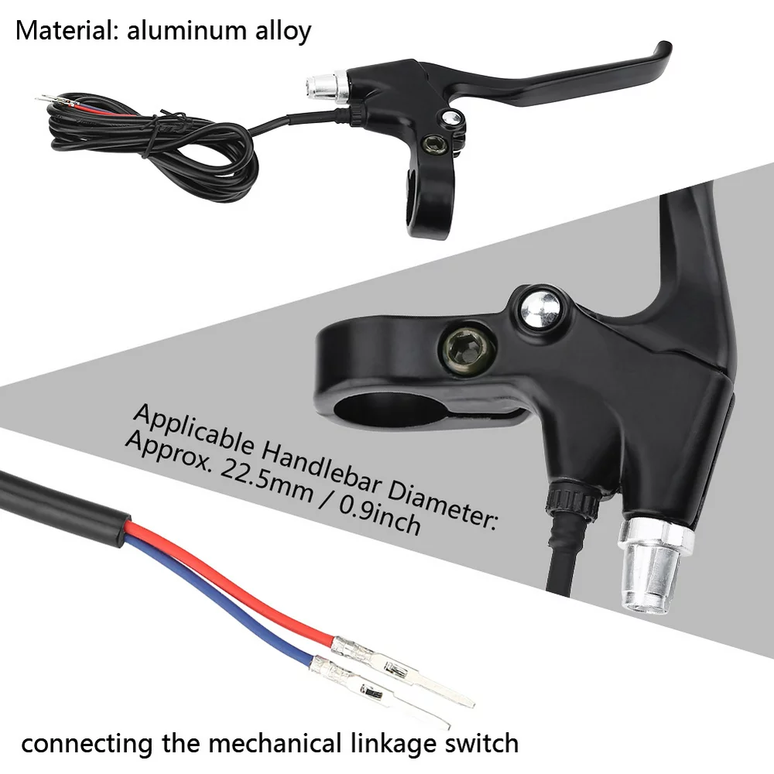

***TESTING***

It is just like a switch.When the brake is pressed both red and blue wires get shorted .

1. ***Head Light***

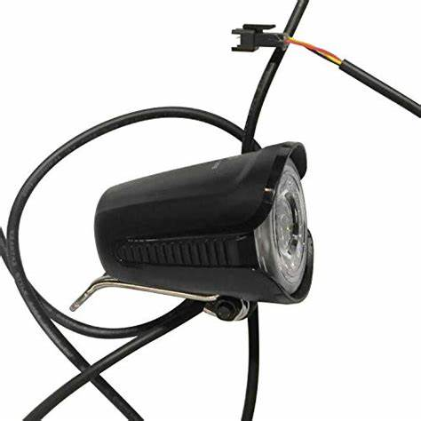

This will work only above 36 volts. We can test this light using a battery.

***5. CONTROLLER DIAGNOSIS***

The input is given to the motor controller through the throttle and the voltage output of the controller phase wires are monitored when the motor and the battery are connected to the controller.

***TESTING***

At a time either one or two of the LEDs glow. If all the 3 leds are glowing together or if none of the leds are glowing then the controller is damaged.

**CIRCUIT FOR TESTING**

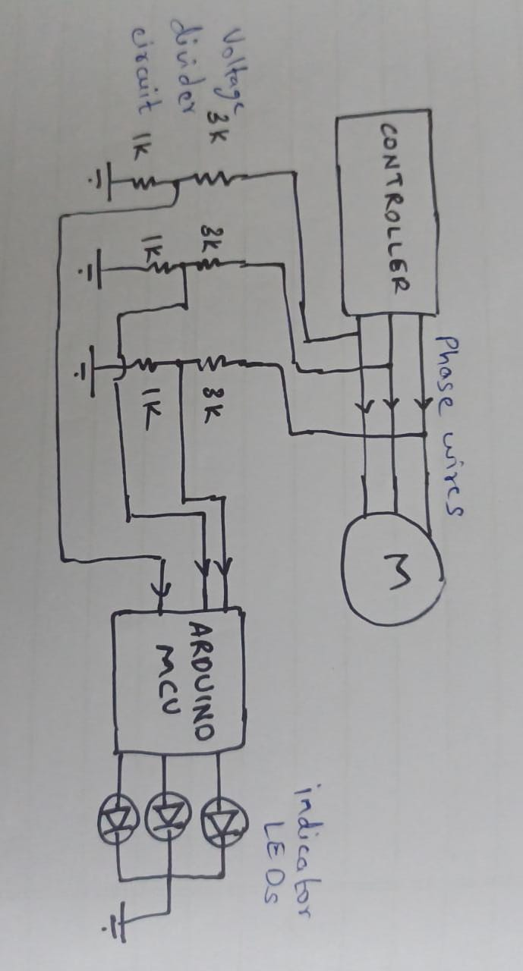

1. The phase wires carry a voltage of 0-18V/21V.
2. The arduino uno microcontroller has been used to measure the voltage in each of the phase wires.
3. As arduino can only read up to 5V, the voltage in each of the phase wires has been reduced to 1/4th of its value using resistor dividers (2 resistors in the ratio 3:1). Hence, arduino receives voltage in the range 0-5.25v.
4. The voltage read by the arduino for each phase wire is given to an LED, which will glow at a brightness proportional to the voltage received by the arduino.

***6. MOTOR PHASE WIRES DIAGNOSIS***

The phase wires of the motor are tested by measuring the back EMF produced in each of the phase wires when the motor is rotated manually, without any load and without connecting the controller.

***TESTING***

If all the LEDs are glowing together constantly or if none of them are glowing then the phase wires of the motor are damaged. For a working motor, the LEDs would flicker and would not glow continuously.

**CIRCUIT FOR TESTING**

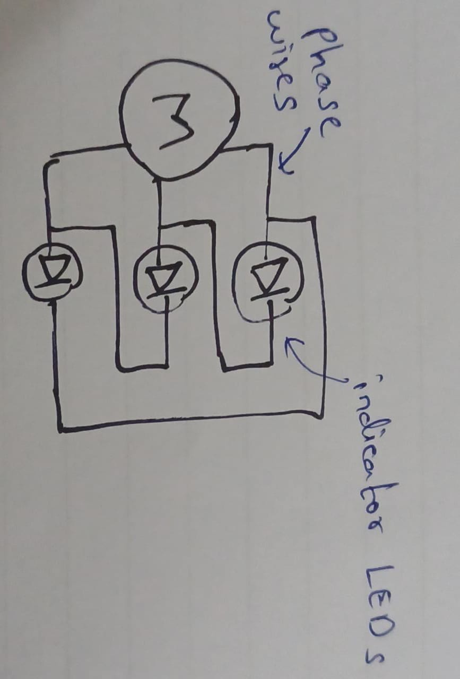

Each phase wire is connected to the anode of an LED and the cathode of each LED is connected to the anode of the LED to its left/right (the last LED’s cathode is connected to the anode of the first LED).

***7. COMBINATION SWITCH DIAGNOSIS***

The combination switch consists of three switches - Horn, Headlight and Pedal assist levels.

***TESTING***

When the buttons for horn and headlight are pressed or when the switch for pedal assist level is slid to 1 or 3, the respective LEDs would light up (as the circuit would get closed and current would flow from the 5v source to ground).

If any LED fails to light up then the switches aren’t working properly.

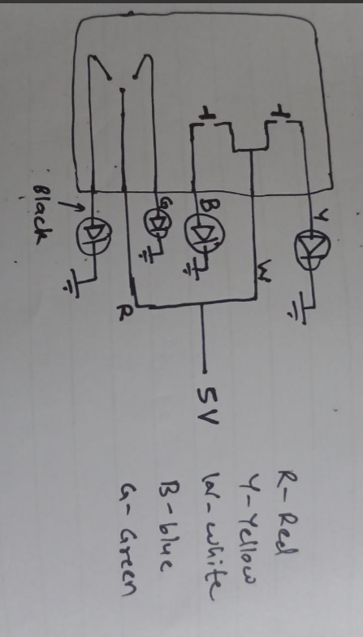

**CIRCUIT FOR TESTING**

The red wire is the common for the 2 way sliding switch for pedal assist level switch. The red wire which goes to 2 is connected to a 5V source. When moved to 1 or 3, the respective circuit gets closed and the LED light’s up, as the green and black wires connected to 1 and 3 are grounded.

For the horn and headlight buttons the white wire is the common, and connected to 5v source.

The yellow and blue wires are grounded, when the horn or headlight switches are pressed, the respective leds light up as the circuit gets closed.